Website Planning
Website Specification
The main objective of our website is to provide information to audience (e.g. Student, Guardians) about us and services we provide.
Goals
To promote our service: we will use our site to showcases packages (e.g. price about 1-to-1 sessions)
To build Reputation and Credibility: Our website we have a section that will be displaying testimonials, our staff reviews and their qualification.
To improve communication: Ours website will have section we our audience will be able to get in contact with ours for more information and inquires.

Targets audience
Parents/Guardians: Because we will be dealing with PSLE and JCE leaners who don’t have a power to choose their tuitions, we will design our website looking at the guardians.
Learners: Educational level BGCSE and IGCSE.
Demographics
Location: Anywhere (causes it a service oriented educational website)
Age:(15-50)because my target a guardians and learners of High-level-education
Education-level: BGCSE and Guardians who can read and write.

Technical Aptitude
My target audience is I people how have the same basic knowledge about web browsing email and online forms. Due to the reasons that many people rely on mobile devices and slow internet, I will make a show that i make my website light weighted to enhance accessibility. I will also make give them option to pay be cash be same having net yet adopted to online payment

My website type
My website is a service oriented educational website its purpose is to provide information to audience (e.g. Student, Guardians) about us and services.
Information Design and Taxonomy
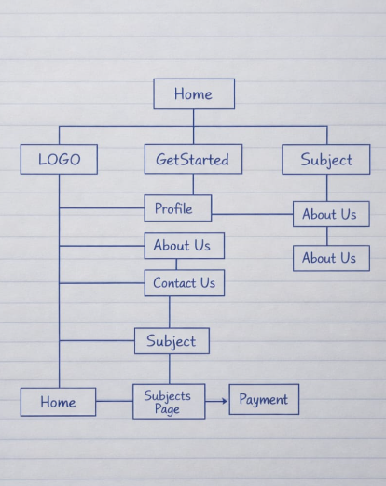

Technical Brief:
Because I have to develop a website which have multiple pages in short span of time, i will be use the following tools speed up speed up process and also make my website more advanced.
Web Developments
HTML5: its on of the newer website languages that have more element used to build web site so I will use it as a language for writing my Source code
and CSS3: Cascading Style Sheet 3 its a language that is used to style and get website ready for presentation I will use it for styling
JavaScript: I will utilise it to add dynamic features.
Bootstrap: Boot Strap it more like a library for HTML and CSS that gives u code for responsive design and layout.

Software Tools
Visual Studio Code:
GitHub: For version control and to publish my website use it on Git hub pages
Graphics Tools
Adobe Photoshop: its one of the most easy to use app for editing image
Canva: It is a software tool used to style my images

Others
Web Browser for running the code (help to check) e.g fire fox, Microsoft or even Safari

